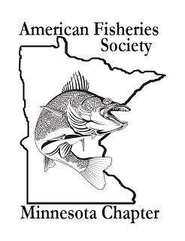
Minnesota Chapter of the
American Fisheries Society
2020 Annual Meeting

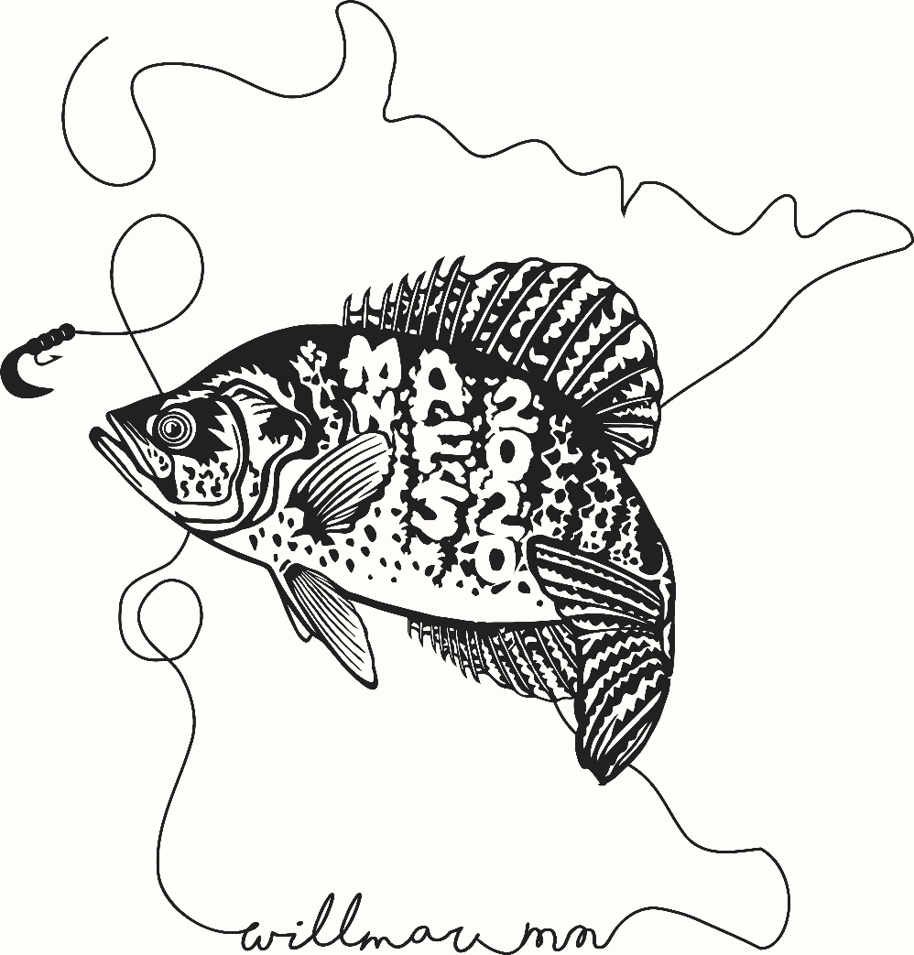

Leaving a Conservation Legacy
President’s Welcome
Welcome to the 2020 Annual Meeting of the Minnesota Chapter of the American Fisheries Society!

Greetings to all who have come to Willmar for our 2020 Annual meeting!

Thank you for taking the time to join us. We hope that you will enjoy the wide variety of oral and poster presentations, workshops, and the plenary session.

The theme of this meeting is “Leaving a Conservation Legacy”. Our plenary and banquet presenters will speak about the future: protective efforts for lakes and watersheds, looking forward with adaptive management for climate change, and engaging anglers for the future. While much of the meeting will look similar to years past, I hope you enjoy some of the changes we made this year, including the 10-minute “lightning talks”. We would very much appreciate any feedback.

This year we are hosting a smaller meeting so I hope you find ample time to network with colleagues and reach out to new associates/students. On a final note, we have moved our business meeting to just after the plenary to encourage more members to attend. I hope to see you there!

Edie Evarts
President - Minnesota Chapter of the American Fisheries Society

AFS Meetings Code of Conduct
- Treat all participants, attendees, AFS staff, and vendors with respect and consideration, valuing a diversity of views and opinions, and critiquing ideas rather than individuals.
- Refrain from demeaning, discriminatory, or harassing behavior and speech directed toward other attendees, participants, AFS staff, and suppliers/vendors.
- Be mindful of your surroundings and of your fellow participants. Alert AFS staff or venue event staff if you notice a dangerous situation or someone in distress.
- Respect the rules and policies of the meeting venue, hotels, AFS-contracted facility, or any other venue.
- To foster a welcoming environment, assist AFS members with impaired physical or cognitive abilities, if necessary.
A BIG thank you to our sponsor in
making this event possible!

To All our Volunteers
Thank you!!!

Paper and Poster Judges
Michelle Krecklau, Rebecca Munter, John Hiebert, Aaron Sundmark, Jessie Koehle, Keith Reeves, Ann Schneider, Mark Pelham, Hannah Anema, Nick Peterson, Morgann Gordon, Paul Glander, David Schumann, Eric Altena, Doug Kingsley, Ryan Lepak, Marc Bacigalupi, Bill Evarts, Steven Hauschildt, Alisha Hallam
Moderators
Matthew Skoog, Heather Baird, Casey Schoenebeck, John Kempe, Brian Nerbonne, Andy Hafs

2020 Annual Meeting Planning Committee
Edie Evarts | President
Craig Kelling | President – Elect
Calub Shavlik | Secretary/Treasurer
Paul Glander | Past President
Kristan Maccaroni | EXCOM/Volunteer Coordinator
Jay Hatch | EXCOM/Scholarships Committee
Jon Hansen | Fund-Raising Committee
Nick Peterson | Fund-Raising Committee
Joel Hoffman | Membership Committee
Hanna Kruckman | EXCOM/Communications Committee
Heidi Rantala | Continuing Education Committee
Tom Burri | Continuing Education Committee
Jessie Koehle | Awards Committee
Patrick Schmalz | Program Committee

Without you, this would not have been possible
Plenary Session
Leaving a Conservation Legacy

Leaving a Lake Conservation Legacy
Paul Radomski
This presentation will provide an overview of some ways that Minnesotans are using conservation easements and land acquisition to protect important lake resources. We will highlight four on-going conservation efforts (wild rice lake protection, sensitive lakeshore easements, forest conservation for lake protection, and cisco lake protection). This presentation will also summarize research on predicting lake water quality and an economic analysis of a set of actions to improve and protect lake water quality. For Minnesota lakes, the investigation concluded that to meet the Clean Water Act’s goals of restoring degraded waters and protecting waters (i.e., the anti-degradation clause) Minnesota should invest a greater share of funds for lake protection, less on those already impaired. The primary focus on impaired lakes results in considerable forgone benefit (~80%) and substantially higher costs -- there is a greater return on investment by protecting high quality lakes than focusing on impaired lakes. Currently, only about 20% of the Minnesota’s Clean Water Fund competitive grants go toward protecting unimpaired high quality lakes at risk. We suggest that policy makers reevaluate the distribution of those funds and that they consider investing a greater percentage to protect lakes at risk before they become impaired.

From the Lake to the Landscape: Managing Freshwater Fisheries under Global Change
Dr. Gretchen Hansen
Freshwater ecosystems and fisheries are experiencing unprecedented rates of change from multiple stressors, including climate change, invasive species, and land-use change. Successful fisheries management under uncertain conditions requires a commitment to scientific thinking and evidence-based decision-making across multiple scales. In this presentation, I will provide a framework for managing fisheries for resilience under conditions of environmental change using principles of science-based fisheries management and drawing on examples from freshwater fisheries in the upper Midwest. This framework focuses on monitoring, landscape-level analyses, managing for resilience, and adaptive management. Because large scale stressors such as climate change can impact fisheries via numerous interacting pathways, responses frequently differ among systems. Understanding this heterogeneity in responses is critical for designing effective management, and requires standardized, stratified monitoring of lakes across the landscape. Landscape-level analyses can help prioritize action in locations where it is most likely to be effective by quantifying heterogeneous responses to environmental change and identifying factors and interactions that promote resilience. Similarly, the effectiveness of management responses cannot typically be measured on a single system -- populations are too variable and measurement tools are too imprecise. Adaptive management can increase resilience of managed fisheries to change while also reducing critical uncertainties, but only when implemented using the principles of experimental design including replication, reference systems, and a commitment to monitoring. Local actions can influence freshwater fish responses to global change, but knowing how, when, and where management is likely to be effective requires a commitment to science-based management.

No Angler Left Inside
Jeff Ledermann
Angler participation in Minnesota is starting to suffer from the same downward trends that have been occurring for a while in other parts of the country. The DNR’s Fish and Wildlife Outreach Program has been working on some new initiatives to stem the decline. Jeff Ledermann, DNR Education and Skills Team Supervisor, will review recent research and planning on R3 (angler and hunter recruitment, retention and reactivation) and how Minnesota is working to buck these trends by reaching new and diverse audiences. He will also highlight the DNR’s R3 Grant programs, including the overwhelming response to the recently released No Child Left Inside Grants.

Plenary Session
Presenter Biographies

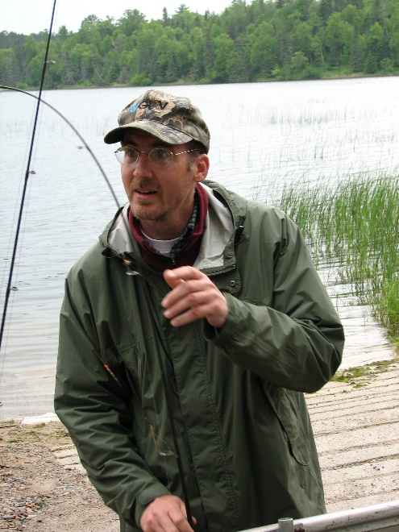
Paul Radomski
Paul Radomski is an old scientist with the Minnesota Department of Natural Resources. He currently serves as Minnesota’s scientific expert on lakeshore habitat management issues. Paul has published over 30 scientific articles on a range of topics including water level management, consequences of climate change on fish recruitment, management of commercial and treaty fisheries, loss of lakeshore habitat, recreational fisheries regulation, loon nesting, aquatic plant monitoring, lead fishing tackle policies, ethics of aquatic non-indigenous plant management, and gill-net selectivity. He, together with Dr. Van Assche, authored a book on lake ecology and lakeshore redevelopment titled Lakeshore Living. He had a major role in the development of model shoreland ordinances, and he assists local governments in lake protection through improved watershed planning and implementation. Paul works out of the DNR Brainerd office, and he is always willing to help lakeshore owners and lake associations better protect their lake.

Dr. Gretchen Hansen
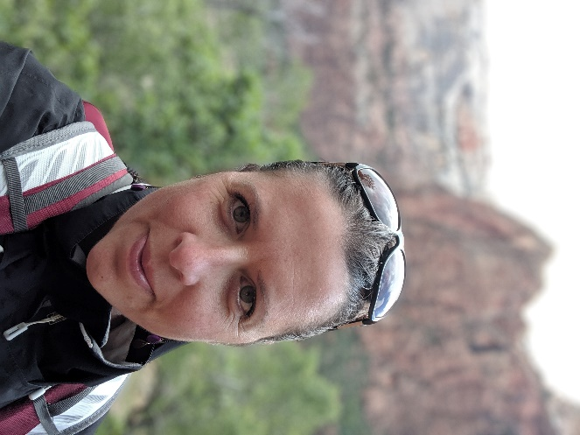
Dr. Gretchen Hansen is an assistant professor in the Fisheries, Wildlife, and Conservation Biology Department at the University of Minnesota. Her research focuses on largescale drivers of change in freshwater ecosystems, including climate, land use, and invasive species. She is especially interested in how local management and lake characteristics influence the resilience of fish populations and communities to regional and global change. Gretchen previously worked as a research scientist for state fisheries management agencies, and is committing to conducting actionable science via collaboration with stakeholders and managers. To answer complex questions she employs multiple approaches including statistical analyses of historical data, observational field studies, simulation modeling, and large-scale experimentation.

Jeff Ledermann
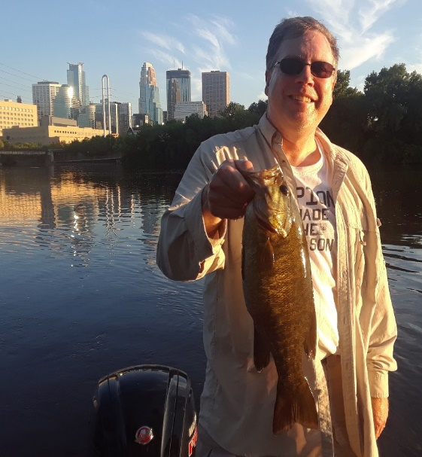
Jeff Ledermann joined the DNR in early 2015 as the Supervisor of the Education and Skills Team in Fish and Wildlife Outreach. His team coordinates a variety of outreach programs, including aquatic and fishing education, shooting sports, Becoming an Outdoors Woman, Governor’s Openers, and skills programs for diverse communities. Jeff has a Master’s degree from Hamline University in Environmental Studies and Education and a Bachelor’s degree in Biology from the University of Minnesota – Morris. He has worked for 28 years for the State of Minnesota in various environmental outreach and education positions. Prior to joining state service, Jeff was a high school science teacher, an In-Fisherman’s Camp Fish staffer and worked for the Minnesota Conservation Corp at DNR’s Farmland Wildlife Research Station in Madelia in the late 80s.

Schedule at a Glance
Monday  February 10, 2020 | Event | Location
12:00 PM – 7:00 PM | Registration Open | Atrium
1:00 PM – 4:00 PM | Continuing Ed | Gallery 1-4
4:00 PM – 5:00 PM | Student Resume Building Workshop | Gallery 1-4
5:00 PM – 7:00 PM | Executive Committee Meeting | Boardroom
5:00 PM – 7:00 PM | Student/Professional Mixer | Gallery 7
7:00 PM – 11:00 PM | Welcome Reception | Gallery 7
Tuesday  February 11, 2020 | Event | Location
7:30 AM – 5:00 PM | Registration Open | Atrium
7:30 AM – 8:30 AM | Continental Breakfast | Hotel Lobby
8:30 AM – 8:45 AM | Chapter President’s Welcome:  Edie Evarts | Gallery 1 - 4
8:45 AM – 9:45 AM | Plenary Session 1: Leaving a lake conservation legacy  Paul Radomski - MNDNR | Gallery 1 - 4
9:45 AM – 10:00 AM | Break | Gallery 1 - 4
10:00 AM – 11:00 AM | Plenary Session 2: From the lake to the landscape: managing freshwater fisheries under global change  Dr. Gretchen Hansen – U of MN | Gallery 1 - 4
11:00 AM – 12:30 PM | Business Meeting | Gallery 1 - 4
12:30 PM – 1:30 PM | Lunch | Off-Site
1:30 PM – 2:50 PM | Concurrent Paper Sessions | Gallery 1&2, 3&4
2:50 PM – 3:10 PM | Break | Atrium
3:10 PM – 4:30 PM | Concurrent Paper Sessions | Gallery 1&2, 3&4
5:00 PM – 6:30 PM | Poster Session | Gallery 5&6
6:30 PM – 8:00 PM | Banquet and Chapter Awards  Speaker: Jeff Ledermann - MNDNR  No angler left inside | Gallery 5 - 7
8:00 PM – 11:00 PM | Social | Gallery 5 - 7

Wednesday February 12, 2020 | Event | Location
7:30 AM – 8:30 AM | Continental Breakfast | Hotel Lobby
8:30 AM – 10:30 AM | Paper Session | Gallery 1 - 4
10:30 AM – 10:40 AM | Break
10:40 AM – 12:00 PM | Paper Session | Gallery 1 - 4

Conference Center information

Best Western Plus and Willmar Conference Center
2100 Highway 12 E
Willmar, MN 56201
320-235-6060

Check In: 3PM
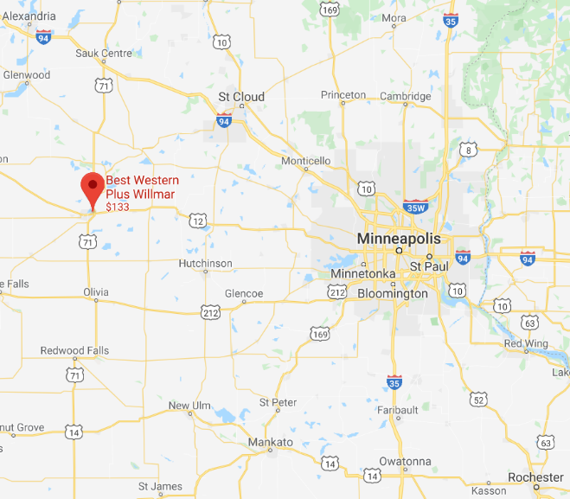
Check Out: 11AM

If you ask someone what the Willmar Lakes Area is known for, how do you think they would answer?
The many beautiful lakes perhaps, but that’s only if they’re unaware of their many unique coffee shops.
The Willmar Lakes Area, a population of just over 42,000 people, is home to 12 unique coffee shops

Concurrent Presentations – Tuesday, February 11
 | Room: Gallery 3&4  Moderator: Matthew Skoog | Room: Gallery 1&2  Moderator: Heather Baird
1:30 PM | Assessing the Dispersal of Stocked Walleye Fry in a Northern Minnesota Chain of Lakes.  Joseph Amundson | Muskellunge Stocking Strategies.  Kristan Maccaroni
1:50 PM | Patterns of baitfish use and release by Minnesota anglers.  Meg McEachran | The "stock what we can get mentality" and moving toward intentional Muskellunge production!.  Craig Soupir
2:10 PM | Assessing the Effects of Double-crested Cormorants on Walleye and Yellow Perch Populations in Leech Lake, Minnesota.  Cody Coyle | New project: Comparing consumption by Muskellunge, Northern Pike, and Walleye populations.  Tyler Ahrenstorff
2:30 PM | 'Tracking the Burbot of Bad Medicine Lake Using VEMCO Positioning System.'  Tyler Robinson | 'Quantifying relations between altered hydrology and biological responses for streams in Minnesota.'  Jeff Ziegeweid
 | Room: Gallery 3&4  Moderator: Casey Schoenebeck | Room: Gallery 1&2  Moderator: John Kempe
3:10 PM | Human Communities Can Benefit From Improving Fish Habitat.  Joel Hoffman | Environmental DNA as a predictor of carp density.  Peter Sorensen
3:30 PM | Use of drawdown as a shallow lake fisheries management tool.  Scott Mackenthun | Common Carp Status and Management in Lake Winona.  Neal Mundahl
3:50 PM | Loss of Minnesota lake ice cover since 1950. Kelsey Vitense
4:00 PM | Quantification and Comparison of Muskellunge and Other Piscivore Diets.  Kamden Glade
4:10 PM | Lessons Learned from Walleye Population Estimates.  Tanner Stevens
4:20 PM | University researchers and Minnesota Master Naturalists study early life history of native mussel species.  Christopher Rounds

Presentations – Wednesday, February 12
Room: Gallery 1-4
Moderator: Brian Nerbonne
8:30 AM | 'Minnesota fish population genetics.  Loren Miller
8:50 AM | Evidence of non-nutrient mechanisms for the sea mount phenomenon on a mid-lake reef complex in Lake Superior.  Thomas Hrabik
9:10 AM | Mercury source changes and food web shifts alter contamination signatures of predatory fish from Lake Michigan.  Ryan Lepak
9:30 AM | Drivers of walleye recruitment across Minnesota's large lakes.  Andrew Honsey
9:50 AM | Are angler-reported lengths of released fish biased?.  Thomas Jones
10:10 AM | An Assessment Model for a Standard Gill Net Incorporating Direct and Indirect Selectivity Applied to Walleye.  Paul Radomski
Room: Gallery 1-4
Moderator: Andy Hafs
10:40 AM | Targeted monitoring for the early life history of 4 fish species.  Casey Schoenebeck
11:00 AM | Minnesota Sentinel Lakes Data.  Tim Martin
11:20 AM | Fish community response to invasion by zebra mussels and spiny water fleas.  Jake Walsh
11:40 AM | Age and growth of a northern Minnesota inland Lake Whitefish population.  Will French

Poster Presentations
Room: Gallery 5&6
Jonah Bacon | The Effect of Winter Severity on Walleye Egg Viability: How Climate Change is Affecting Walleye Populations in Minnesota
Naomi Blinick | Zebra mussel impacts on walleye populations and mercury concentrations
Brad Morris | Effects of Spiny Water Flea on Sportfish Assemblages in the Canadian Shield, Minnesota
Morgann Gordon | Habitat use by Lake Sturgeon (Acipenser fulvescens) using acoustics and stable isotopes
Olivia Graziano | Trout Redd Surveys Across Multiple Streams within the Driftless Region in southeastern, MN
Mitchel Johansen | Determining Perch Age by using Otolith Weight and Size
Holly Kundel | Quantifying the impacts of zebra mussels on walleye recruitment in Minnesota lakes
Daniel McCann | Yellow Perch Diets in Zebra Mussel Infested Lakes
Kristina Pechacek | Habitat use, thermal distribution, and diet of Brook Trout (Salvelinus fontinalis) as affected by interspecific competition with non-native Brown Trout (Salmo trutta) in the Driftless Region of southwest Wisconsin.
Kristina Rands | Morphological Lake Characteristics in Comparison to Age-0 Yellow Perch Hatch Rates
Jeffrey Reed | Male Largemouth Bass Reproductive Participation and Nesting Phenology in North-Temperate Lakes
Christopher Rounds | Digitizing lake depth data using ImageJ
Bryan Sea | Shallow lakes fish ecology, using Northern Pike Esox lucius and Yellow Perch Perca flavescens to attempt a trophic cascade.
Anthony Sindt | Minnesota River Channel Catfish population dynamics upstream and downstream of Granite Falls Dam
Alicia Skolte | Implications of management actions (land-use changes and vegetation removal) on condition shifts due to trophic cascades.
Andy Riesgraf | Integrating a sound/light deterrent and dam gate operations at Lock and Dam 8, Mississippi River to reduce upstream migration of Common Carp (Cyprinus carpio)
Paige Wiehr | Comparison of Summer and Fall Walleye Gill Netting
Jeffrey Ziegeweid | Modelling egg transport and hatching success to investigate the likelihood of invasive carp populations becoming established in the lower St. Croix River

Notes

