Montana Chapter of the American Fisheries Society
59th Annual Meeting

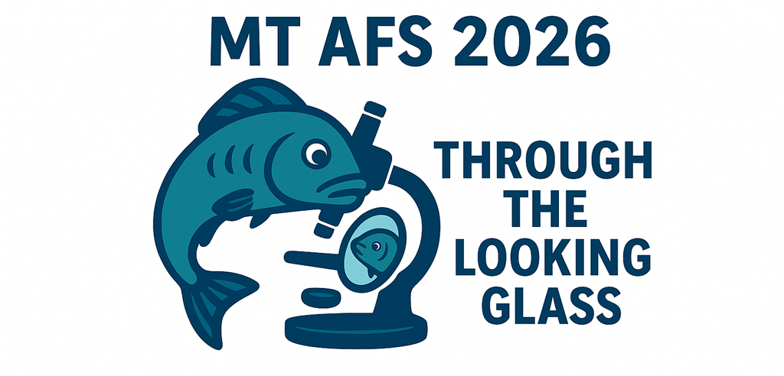

February 10-13, 2026
Fairmont Hot Springs Resort
Fairmont, MT

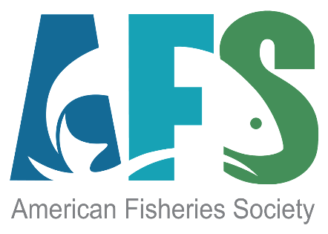
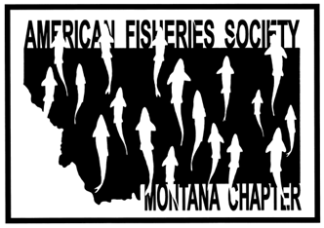

montana chapter of the american fisheries society

2026 Annual Meeting

Schedule At A Glance

Tuesday, February 10 | 8:00 am – 12:00 pm  12:00 pm – 1:00 pm  1:00 pm – 5:00 pm  6:00 pm – 9:00pm |  | Continuing Education Session TBD  Lunch (on your own)  Continuing Education: MEPA/NEPA  Welcome social (dinner provided) |  | Ballroom
Wednesday, February 11 | 7:30 am  7:30 am – 8:30 am  8:30 am – 12:00 pm  12:00 pm – 1:30 pm  2:00 pm – 4:40 pm  4:45 pm – 5:45 pm  6:00 pm – 9:00 pm |  | Registration  Breakfast buffet  Plenary Session: Through the Looking Glass  Lunch (provided) – Poster & Art Show  Contributed Papers  Committee Meetings  Student Mentoring Social (dinner provided) |  | All events in Ballroom
Thursday, February 12 | 8:00 am  7:00 am – 8:00 am  8:00 am – 12:00 pm  12:00 pm – 1:10 pm  1:15 pm – 4:40 pm  4:45 pm – 5:45 pm  6:00 pm – 9:00 pm |  | Registration  Breakfast buffet  Contributed Papers  Business Lunch (provided)  Contributed Papers  Montana Association of Fish and Wildlife Biologists Meeting  Banquet, Awards & Raffle (dinner provided) |  | Ballroom  TBD  Ballroom
Friday, February 13 |  |  | ONLY IF NEEDED
Networking Events
Welcome Social |  | Tuesday February 10 |  | Dinner provided |  | Ballroom
Poster & Art Show |  | Wednesday February 11 |  | Lunch provided |  | Fireplace Foyer
Student-Mentor Social |  | Wednesday February 11 |  | Fish Trivia by U of M Students  Dinner Provided |  | Ballroom
Banquet, Awards and Raffle |  | Thursday February 12 |  | Awards Banquet  Raffle provided by MSU Students  Dinner Provided |  | Ballroom

