SDAFS Catfish Committee Chair Playbook
Updated: 8/10/2020 (A. Bunch)
Updated: 1/13/2021 (K. Bodine)
Updated: 8/15/2024 (L. Wright)
Table of Contents
I. Suggested Timeline for Deadlines
II. Introduction to Duties and General Information
III. EXCOM Members
IV. Catfish Technical Committee Meeting Duties
V. Duties For Compiling and Submitting Catfish State Reports
VI. Student Travel Award
VII. Communication to SDAFS Catfish Committee Members
VIII. Communication to AFS Catfish Listserv
IX. Web Page Updates
X. Submitting SDAFS Annual Report
XI. Ad Hoc Items
XII. Awarding Previous EXCOM
XIII. Previous CMTC Officers
XIV. Previous CMTC Travel Award Winners

- Suggested Timeline for Deadlines
March 30 – Send email to keep listserv fresh
June 30 – Send email to keep listserv fresh
September 30 – Send email to keep listserv fresh
September/Early October – Announce Student Travel Award Application
November/Early December – Request submission of state reports by state reps
Mid November – Approximate deadline for Travel Award
Early January – Approximate deadline for submission of state reports.
Early December – EXCOM meeting to discuss and select a Travel Award winner.

- Thank you for your willingness to serve as Chair for the best committee in the Southern Division of AFS. This position requires a two-year appointment. The key is follow-through and leadership. Be sure to read the SDAFS Procedures and Bylaws document that outlines how committees should operate. The following pages will show the basic needs of the committee.
Committee Chair Responsibilities:
- Lead Annual Catfish Committee meeting at each SDAFS meeting.
- Gather, compile, and disseminate annual catfish state reports ahead of the meeting.
- Lead the effort to advertise and select a recipient of the SDAFS Catfish Committee Travel Award.
- Periodic communications with EXCOMM and the Catfish Committee.
- Lead and oversee the “AFS Catfish Listserv” through the AFS email Dodo account.
- Submit SDAFS Annual Report.
- Ad hoc items.
- Awarding previous EXCOMM.
Committee Chair-Elect Responsibilities:
- Substitutes for the Chairperson in that officer's absence.
- Works with the current chair to become familiar with the responsibilities of the chair position.
Secretary/Treasurer Responsibilities:
- Presents the treasurers report and prepares a year-end financial balance report.
- Produces minutes for each meeting.
- Purchase plaques for outgoing executive committee members.
- Provides check for student travel award recipient.
Webmaster Responsibilities:
- Completes webpage updates as needed.
- Uploads meeting minutes and state reports.
State Representative Responsibilities:
- Compile and summarize list of catfish management and research projects from each representative’s state to the committee chair to be included in the CMTC state report. Individual state reports are typically requested by the committee chair in November/December each year. See appendix B and C for report format example.

- Executive Committee Positions and Term Limits
- Committee Chair: Selected for two-year term. May not serve more than two consecutive years.
- Chair-Elect: Selected for a one-year term to run concurrent with the final year of the current Chairperson's term.
- Secretary-Treasurer: Selected for two-year term.
- Webmaster: No defined term limits

- Lead Annual Catfish Committee meeting at each SDAFS meeting
Chair will work with SDAFS to develop a half-day time slot during the SDAFS spring meeting. Since 2017, this meeting has also been offered virtually through various meeting platforms to make it available to all members. Be aware that using hotel A/V staff assistance will incur a cost, so this will need to be arranged without A/V staff help in order to avoid a large unreasonable charge. This can be achieved by taking advantage of a meeting platform software you have available to you, or others in EXCOMM. You can also seek assistance from other committee members.
Prior to 2017, meetings primarily consisted of general discussions surrounding catfish in AFS through a roundtable discussion where each state representative spoke. Since that time, the committee has taken a different approach since all reports are all supplied ahead of the meeting. This has helped to accommodate a session dedicated to the presentation from the travel award winner. Please see Appendix A for a previous agenda.

V. Gather, compile, and disseminate annual catfish state reports
Primary duty here is to send communication to the catfish committee with deadlines for you to receive state reports. Some representatives are attentive to this, and others take some prodding. If you send an email close to the deadline that shows all the states that have reported, those other state representatives tend to get their act together, and send along shortly thereafter. This is also a good opportunity to update the list of state representatives serving on the committee as those can change. See Appendix B for the standard form, and Appendix C for formatting each state together into a streamlined document.

VI. SDAFS Catfish Committee Travel Award
In 2015, the SDAFS Catfish Committee Travel Award ($1000) was created to engage students directly with the committee. Each September, the Chair should announce the SDAFS Catfish Committee Student Travel Award application process. Announcements and appropriate deadlines should be posted to the Catfish Committee website, the SDAFS Facebook page, the SDAFS listserv (cottre2@g.clemson.edu), and also to all SDAFS Catfish Committee State Reps. Deadlines can be set by the EXCOM; just allow enough time to process, select a winner, and provide enough time for the winner to prepare a presentation for the upcoming SDAFS meeting.
When an SDAFS meeting occurs in-person, the student is required to also attend in-person. When held virtually, the student is required to attend the virtual meeting. Currently, the EXCOM ranks applicants individually, and a conference call is held to discuss the winner. There is room for improvement for how this process works. Feel free to work with the EXCOM to develop a standardized process for rating applicants. See Appendix D for previously used instructions.

VII. Periodic communications with SDAFS Catfish Members
This is important to keep efforts going throughout the year beyond the SDAFS meeting. It is important to have at least two conference calls with EXOMM to get updates on any initiatives and to discuss financials with the secretary-treasurer. The frequency may vary depending on current initiatives by the committee.
An email to the committee would be ideal every 4 months to keep committee in their minds throughout the year. Past items for consideration were updating regulations table on the website, adding additional publications to the references website, and communication on Catfish 2020.

VIII. AFS Catfish Listserv
The AFS Catfish Listserv was developed to increase communication throughout AFS. This is not solely an SDAFS email list, thus, communication through this email list should be reserved for communication not specific to SDAFS. The AFS Staff contact for the listserv is Beth Beard bbeard@fisheries.org. Messages can be posted to the listserv by sending an email to catfish@afsmembers.org.
The Chair’s job will be to moderate, add members, and advertise that it is available to catfish researchers within AFS. This can be done through Social Media or other venues. The moderator must add in emails individually into the Email DoDo website.
Chairs should periodically post something to keep it fresh in people’s minds. Consider sending an annual email to this group to determine if there is anyone who needs removed or added to the list.

IX. Webpage updates
Chairs must work with SDAFS to keep website updated, especially when EXCOMM officers and contact information changes (Appendix E). The committee has a dedicated webpage that houses all important information we share with the world. The student travel award is linked there along with past workshop information, committee member publications, state regulations table, and state reports from previous years. https://units.fisheries.org/sdafscatfishcommittee/. A member of the committee will serve as web master to handle updates you send them. The web site is maintained using Word Press and can be edited by going to https://units.fisheries.org/sdafscatfishcommittee/wp-admin/ and logging in. Contact the web master if you would like editing privileges.
For webmaster or other people with editing privileges, you can edit the web site by going to https://units.fisheries.org/sdafscatfishcommittee/wp-admin/.
Adding links to SD Catfish web page:
- Go to “Pages” and select “edit” under the page you want to work on.
- Click on the page where you want the link.
- Click on the “Add Media” icon at the top of the editor area.
- Browse to the file you want to upload using windows Explorer, then drag and drop the file onto the WordPress Insert Media page.
- On the right side of the insert media page under “attachment details” change the “Title” to the text you want your link to have once it is inserted in the web page.
- Click “insert into page” at bottom right and a link to the uploaded file will be inserted using the “title” text in the original page where your cursor was located when you started the upload.

Routine tasks for webmaster:
- Post the state reports once the chair has them compiled (might be before or after the meeting).
- When posting meeting minutes. We generally start with unapproved (i.e., not yet voted on by membership) minutes. The easiest way to deal with this is to add a watermark in MS Word (Design ribbon, then “Watermark” in the “design” section) to stamp “Draft” on the document, then export it as a pdf. Once the minutes are approved at the next meeting, any needed edits can be made, and a PDF saved without the watermark on them to replace the original link.
- Update the student scholarship document, if needed and requested by the scholarship committee.
- After electing new officers, the officer page at the web site should be updated (move current committee chair to the list of past chairs to maintain history).
- Add winners of the student scholarship to the scholarship page. Is nice if we can also add a picture of the student.

X. SDAFS Annual Report
Each committee is responsible for submitting an annual report of activities to SDAFS leadership (Appendix F). Work with SDAFS leadership to understand deadlines. All catfish committee-related items can be listed on the form (Appendix F).

XI. Ad hoc items
There will be initiatives that come and go perhaps requiring “ad hoc” sub-committee or projects. One such item in the past has been SDAFS continuing education training sessions led by the committee. The committee has been involved with age and growth workshops in past meetings. It is the Chair’s responsibility to work with SDAFS planners or delegate responsibility to willing members who would be involved in the training session.

XII. Awarding previous EXCOMM
The committee offers plaques to outgoing members of the EXCOMM. Chairs should arrange with the secretary-treasurer to purchase plaques for EXCOMM members who have finished their terms for the committee, as appropriate. Those should be ordered by secretary-treasurer with help from the Chair-elect to ensure the outgoing Chair and Secretary-Treasurer is awarded a plaque at the SDAFS meeting.

XIII. Previous Catfish Management Technical Committee Officers
Year | Chair | Chair Elect | Secretary/Treasurer | Webmaster
2004 | Elise Irwin | Dave Buckmeier | Peter Sakaris
2005 | Elise Irwin | Dave Buckmeier | Peter Sakaris
2006 | Dave Buckmeier | Kevin Sullivan | Peter Sakaris
2007 | Dave Buckmeier | Kevin Sullivan | Jason Olive | George Scholten
2008 | Dave Buckmeier | Kevin Sullivan | Jason Olive | George Scholten
2009 | Kevin Sullivan | Jason Olive | Zack Brown | George Scholten
2010 | Kevin Sullivan | Jason Olive | Zack Brown
2011 | Jason Olive | Bob Greenlee | Mike Holley | Dan Shoup
2012 | Jason Olive | Bob Greenlee | Mike Holley | Dan Shoup
2013 | Bob Greenlee | Tim Bonvechio | Chas Patterson | Dan Shoup
2014 | Bob Greenlee | Tim Bonvechio | Chas Patterson | Dan Shoup
2015 | Tim Bonvechio | Jerry Brown | David Wellman | Dan Shoup
2016 | Tim Bonvechio | Jerry Brown | David Wellman | Dan Shoup
2017 | Jerry Brown | Arron Bunch | Eric Ganus | Dan Shoup
2018 | Jerry Brown | Arron Bunch | Eric Ganus | Dan Shoup
2019 | Arron Bunch | Kris Bodine | Joe McMullen | Dan Shoup
2020 | Arron Bunch | Kris Bodine | Joe McMullen | Dan Shoup
2021 | Kris Bodine | --Vacant-- | Joe McMullen | Dan Shoup
2022 | Kris Bodine | John Tibbs | Joe McMullen | Dan Shoup
2023 | John Tibbs | --Vacant-- | T.D. VanMiddlesworth | Dan Shoup
2024 | Lynn Wright (interim) | --Vacant-- | T.D. VanMiddlesworth | Dan Shoup
2025 | Lynn Wright | --Vacant-- | T.D. VanMiddlesworth | Jeremiah Duck
2026 | Lynn Wright |  | T.D. VanMiddlesworth | Jeremiah Duck
2027
2028
2029
2030
2031
2032

XIV. Previous CMTC Travel Scholarship Award Winners
Name | Year | Organization
Joseph Schmitt | 2016 | Virginia Tech University
Zach Moran | 2017 | Arkansas Tech University
Corbin Hilling | 2018 | Virginia Tech University
Vaskar Nepal | 2019 | Virginia Institute of Marine Science
Bobby Cope | 2020 | North Carolina State University
No applicants | 2021
No applicants | 2022
No applicants | 2023
Yesutor Soku | 2024 | Tuskegee University
Justin Kowalski | 2025 | Auburn University
 | 2026
 | 2027
 | 2028
 | 2029
 | 2030
 | 2031
 | 2032

Appendix A.

Appendix B.
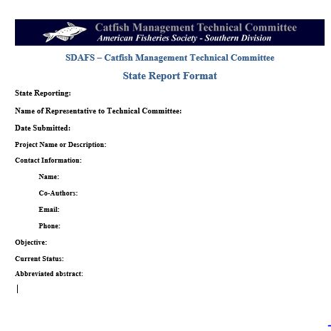

Appendix C.
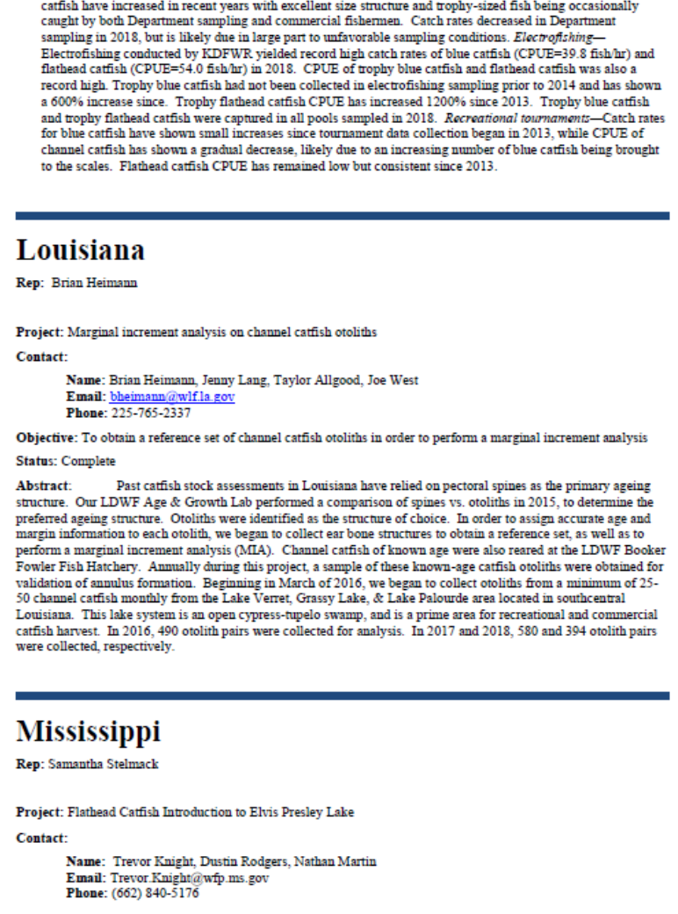

Appendix D.

Catfish Management Technical Committee Student Scholarship
This scholarship was created at the spring 2015 Southern Division meeting to provide financial assistance to a graduate student in the southeastern United States (Alabama, Arkansas, Washington D.C., Florida, Georgia, Kentucky, Louisiana, Maryland, Mississippi, Missouri, North Carolina, Oklahoma, Puerto Rico, South Carolina, Tennessee, Texas, Virginia, Virgin Islands, West Virginia) who is studying catfish-related fisheries management. CMTC officers (Chair, Secretary-Treasurer, Chair-Elect, & Webmaster) will review the applications and select the award winner.
The AFS Southern Division Annual Meeting will be held from February 18th through February 21st, 2025, in Ashville, North Carolina. The Catfish Management Technical Committee (aka. Catfish Committee) will offer one $1000 scholarship to enable a student conducting catfish research to attend the meeting. Priority will be given to applicants whose research focuses on management or ecology of catfish. This award will be made directly to the student and not the student’s educational institution. Award recipients will be required to present the results of their study during the Catfish Technical Committee Meeting on Tuesday, February 18, 2025. If there are no applicants that can attend the meeting in person, then applicants who plan to attend virtually will be considered for a reduced $250 award.
The deadline for submitting the required information to the committee chair (Lynn Wright, lynn.wright@tpwd.texas.gov) is November 15, 2024. The chair will distribute copies to the award committee members.
Instructions:
- Include a cover letter introducing yourself.
- Complete the enclosed award application.
- Provide a copy of your research proposal indicating its relevance to catfish fisheries management and research in the southeastern United States.
- Provide an abstract detailing what you will be presenting to the committee.
- Submit the cover letter, award application, research proposal and abstract to the committee chair via email no later than November 15th, 2024.
The award committee will notify the successful applicant by December 6, 2024. The winner will be presented with an award check following their presentation to the committee on February 18, 2025.
Winners of the scholarship are encouraged to present their research at future AFS meetings.

Appendix E.
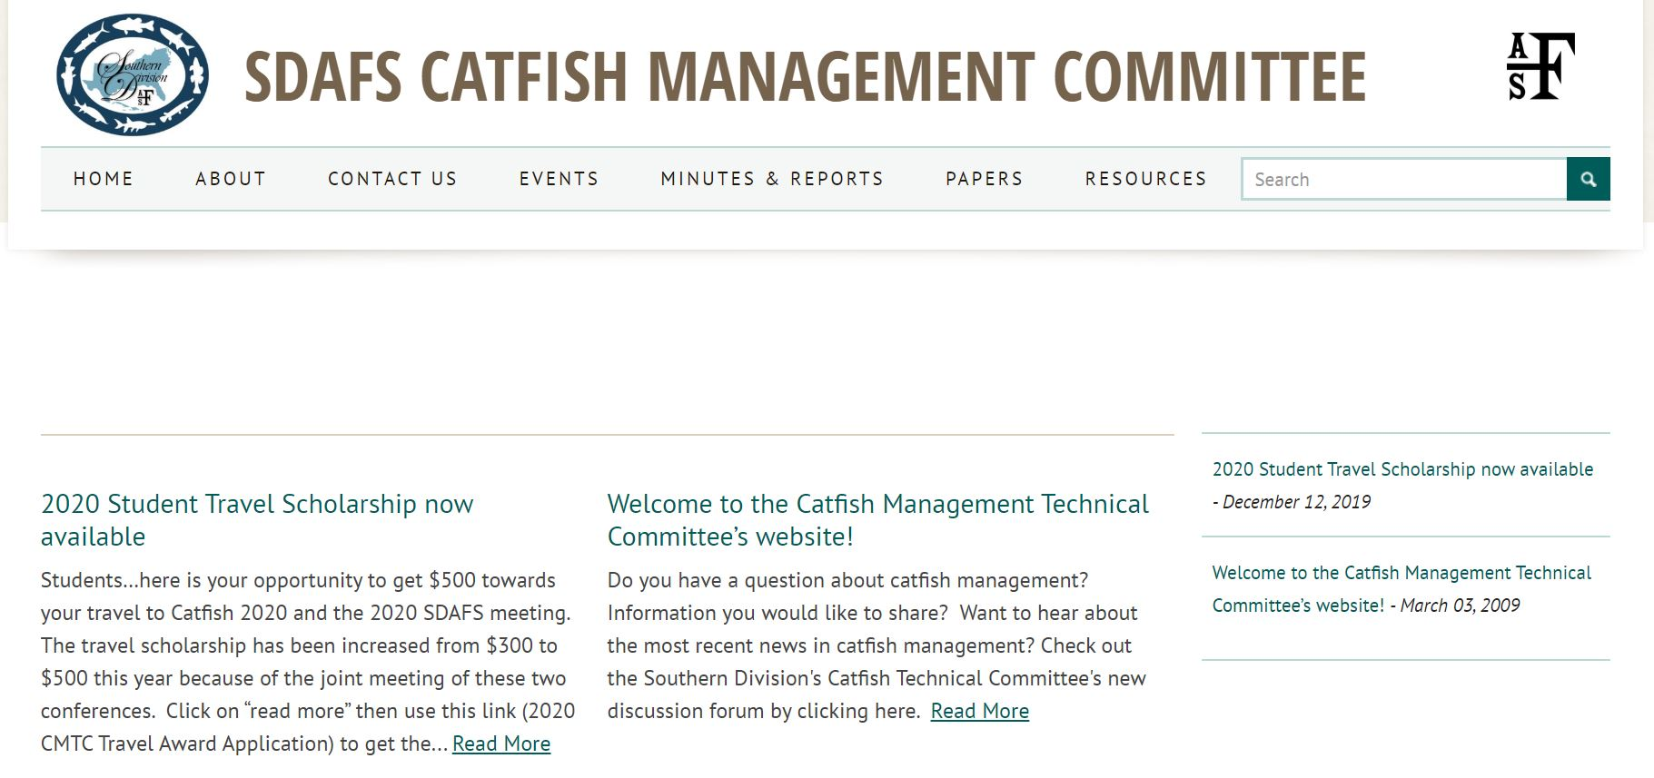

Appendix F.
2019 Southern Division AFS Annual Report
(Based on Strategies and Information Needs of the AFS Governing Board)

Chapter or Subunit: SDAFS Catfish Committee
President: Aaron Bunch (chair)
Person completing report: Aaron Bunch (chair)
Date: 1/17/2020

Strategy 1. Organize and sponsor forums to present new findings and exchange ideas.
What meetings did your subunit host, sponsor, or were affiliated with?
Name of the meeting(s) | Committee Meeting during 2019 SDAFS meeting in Galveston, TX
Number of Attendees (Include information on Regular, Student, Young Professional, and Retired Attendees, if available) | 21 attendees (in-person & webinar); of those, 3 were students
Was there a student mentoring activity? (Information on how many mentors and mentees participated, if available?)
Number of symposia
Number of symposia presentations (student and professional), and posters (student and professional)
Number and value of travel support given to students | SDAFS Annual Meeting: 1 @ $300
Number of students provided with travel support | 1
Early, Regular, and Late registration costs, registration costs for students, young professionals, and/or retirees
Meeting net proceeds (total revenues minus expenses)
Target audience of meeting | State & Federal agency biologists, University professors & students, Private Sector biologists, and AFS members & Catfish Committee reps
Amount of financial support provided by the unit

Strategy 2. Provide continuing education opportunities with an emphasis on training and courses that are not commonly offered by academic institutions and/or that will be essential tools in the future.
Category or subject of training or course
(e.g. GIS, Leadership, Electrofishing, Habitat, Data Analysis)
Number of attendees
Length of course
Instructor fees and/or course registration fees

Strategy 3. Develop communication materials and publicly accessible information to promote the value of fisheries, aquatic habitat, and fisheries science. (Note: Report information related to website or social media communications under Strategy 7)
Type of communication
(e.g. newsletter, lay article, promotional material, etc.)
Frequency of communication
Targeted audiences
Intended range of communication
(e.g., regional, national, international, etc.)

Strategy 4. Develop relationships, partnerships, and collaborations with other professional societies, conservation organizations, decision makers, and stakeholders to establish and promote mutual goals of fisheries science, education, and stewardship.
.Provide names of organizations and how the relationship advanced AFS priorities; including, NGOs, professional organizations, fishing clubs, elected officials, etc.

Strategy 5. Publish high quality scientific journals, books, and proceedings that present recent advances, reviews, and syntheses of fisheries and aquatic science and management.
(This strategy not intended to capture individual member’s publications. Website-related activity should be reported under Strategy 7)
Type of publication (e.g., text book, symposium, journal)
A brief description of the publication’s topic
Distribution or number of published copies

Strategy 6. Develop and disseminate scientifically-based communication materials that represent and reflect the mission of the Society to political leaders, decision makers, stakeholders, and the public.
Letters
Briefing/White Paper
Public hearing
Letter to the editor
Provide brief descriptions of materials
Targeted audiences
Distribution numbers

Strategy 7. Provide online resources of value and interest to members and non-members.
(For the sake of the Southern Division’s report, just report whether you use each online resource)
Unit’s website: date of most recent update, number of visitors per month over the reporting period, most viewed pages | https://units.fisheries.org/sdafscatfishcommittee/ (Dec. 12, 2020 update)  Website includes catfish related publications, previous workshops, and a spreadsheet of catfish regulations (updated in 2019)
Listserv: number of members and of messages distributed over the reporting period | AFS Catfish Listserv was created for all catfish related information within AFS, but is moderated by SDAFS Catfish Committee Chair  102 members currently (1-17-2020)
Facebook: number of posts, “likes”, “followers”, “shares”, “group members”, “people reached”
Twitter: number of tweets, followers, retweets and impressions, most popular tweet based on number of retweets | N/A
Linkedin: number of members/followers, discussion strings, most popular discussion | N/A
Photo/video (Instagram/YouTube, etc): number of views or people reached, explain value to AFS members | N/A

Strategy 8. Certification program. Explain what type of activities are being conducted to promote certification among Unit members.

Strategy 9. Use of innovative techniques to determine and respond to the needs and opinions of Society members, such as Surveys, Focus Groups, and Linkedin Discussion Groups
Survey given to members to figure out who would be attending committee meeting through webinar

Strategy 10. Report new technologies used by the Unit to enhance or expand Society’s communications, networking, and advocacy activities and their outcomes. Those may include: online forums, online surveys/voting, meeting app, and changes to website
AFS Catfish Listserv was created for all catfish related information within AFS, but is moderated by SDAFS Catfish Committee Chair
102 members currently (1-17-2020)

Strategy 11. Activities conducted by unit to improve participation of students and professionals at all levels to assure recruitment, retention and leadership development. Examples: membership drive and EMLA/leadership training
Our travel award was specifically created to increase student participation. We had one of the previous winners attend in 2019.

Strategy 12. Activities conducted by your unit promoting demographic and disciplinary diversity within the Society and fisheries profession. Those may include: recognition for students and underrepresented groups; formation of new student subunit; and contribution to Hutton and Skinner program

Strategy 13. List types and number of awards (monetary and non-monetary) granted within the reporting period.
- SDAFS Catfish Committee Travel Award - $300

Strategy 14. Information regarding Excom meeting, and other Unit governance meetings of elected officers, number of participants, elections, number of votes: Annual business meeting, leadership retreat, financial audits, elections
(*active committees should be addressed in Strategy 1)
The SDAFS Catfish Committee Excom (Chair, Chair-elect, and Secretary-Treasurer) had 3 conference call meetings throughout the year

Strategy 15. Any periodical reviews of the unit’s constitution, bylaws and procedures.

