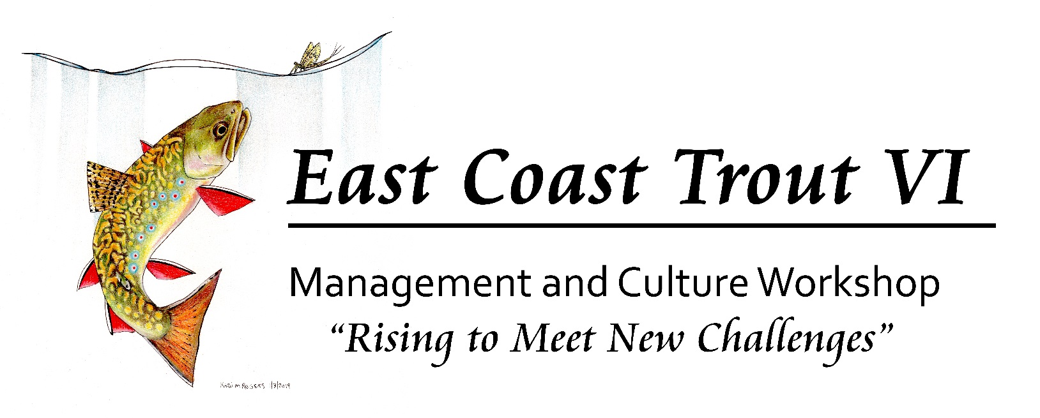
June 10 - 12, 2019
Frostburg State University, Frostburg, MD
Call for Papers – EXTENDED DEADLINE, APRIL 12, 2019
The Southern Division AFS Trout Committee announces the Final Call for Papers with an extended deadline for the 6th East Coast Trout Management and Culture Workshop, June 10 - 12, 2019, at Frostburg State University in Frostburg, Maryland. This workshop is unique in providing a forum for fisheries biologists and administrators, trout culturists, academic researchers, students, fishing conservation organizations, and anglers to share information, techniques and timely topics of concerns.
A focus of this meeting will be the importance of biosecurity for management and culture efforts in an increasingly mobile world of anglers, fisheries researchers, and culture professionals. From headwater native brook trout streams to multi-species tailwater fisheries, the importance of considering, planning, and managing for biosecurity issues is critical to the future of our coldwater resources. With this focus, a half-day symposia and panel discussion is being planned in addition to the regular session topics.

This Sixth East Coast meeting presents a continuing opportunity for an incredibly diverse gathering of individuals interested in our cold water resources to gather and discuss vital issues facing the future of these resources. Towards this end we are especially encouraging presentations on the following topics in addition to the biosecurity focus, with the expectation that the information exchanged and discussed at the meeting will lead to actions and direction for coldwater management in the future. The topics are:

- Biosecurity measures and their impacts to coldwater management
- eDNA application for wild trout inventory and monitoring
- Stream restoration for native and wild trout: biological success stories and why they worked
- The future of coldwater culture: meeting resource and management needs in the face of budget, biological, and biosecurity challenges
- The role and value of developing and continuing long term data sets for coldwater fisheries
- Aquatic nuisance species impacts on coldwater resources
- New opportunities and techniques in coldwater production
- Social media role(s) in communicating with the angling public and media
- Recruit, retain, reactivate; how do we approach coldwater fisheries marketing and promotion?
- Is there compromise when science conflicts with stakeholder desires in coldwater fisheries management?
- Practical applications of genetics research and data for todays’ fisheries and culture managers
- Climate warming predictions and potential impacts to east coast fisheries resources – are we being proactive?
- Balancing conflicting resource use desires between anglers, landowners, recreational interests, and private industry for tailwater fisheries
- The role of coldwater hatcheries in native trout restoration and wild trout fishery establishment
- Modeling and predictive programming to steer habitat restoration projects

Fisheries managers, culturists, researchers, administrators, and anglers are encouraged to attend this workshop and to submit an abstract(s) for review and inclusion in the workshop program. Presentations will be 20 minutes in length and may include reviews of pertinent works and recently completed studies or preliminary results that are innovative solutions to the challenges we face in managing our coldwater resources. Those wishing to present at this workshop must send an abstract to Matt Sell (matt.sell@maryland.gov) for management and culture topics by APRIL 12, 2019. Abstracts or extended abstracts should be in MICROSOFT WORD format and follow the instructions for authors in the Manuscript Format section for the North American Journal of Fisheries Management (NAJFM). Abstracts can be up to four, double spaced pages with additional tables and figures. All accepted abstracts will be published in the meeting proceedings, and should include a title, name and address of each author, and the telephone number and email address of the presenter.
In addition, the EBTJV Steering Committee (June 12, 1:00- 5:00 @FSU) and the SDAFS Trout Committee (June 13, 8:00 a.m. - 12:00 noon, UMCES Appalachian Lab, Frostburg) will conduct their annual meetings in conjunction with the East Coast Trout Workshop.

Meeting registration should be done online by visiting the meeting registration website (click HERE to register). Rates for optional on-campus lodging (FSU air conditioned dormitory rooms with linens, single or double), catered box lunch on Tuesday, and the Tuesday night social (with dinner, live music, and cash bar) are available at the registration website. Payment is due via credit card at the time of registration through PayPal (link provided after you submit your registration). If you cannot pay via credit card, please contact Matt Sell or Alan Heft (contact information below) prior to registration to arrange other payment options. Local lodging, restaurant, and other visitor information is available at the Visit Frostburg website. Private lodging is available at a group rate at the following locations;

Holiday Inn Express, LaVale, MD – ~10 minutes from campus
Make a reservation by calling; 301-729-4800
Group Rate: $93/night + tax, double queen

Hampton Inn, Frostburg, MD – less than 5 minutes from campus
Make a reservation by calling; 301-689-1998 and use group code: OEC
Group Rate: $124/night + tax, double queen or single king

Quality Inn, Frostburg, MD – less than 5 minutes from campus
Make a reservation by calling; 301-689-2050 and reference the East Coast Trout Meeting
Group Rate: $86/night + tax, double queen or $96/night + tax, single king

For additional meeting information contact Matt Sell (matt.sell@maryland.gov) or Alan Heft (alan.heft@maryland.gov).

