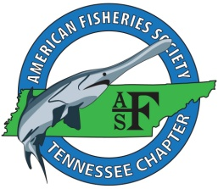

**Tennessee Chapter of the American Fisheries Society**

**2014 Newsletter**

**A Letter from the President**

This year started off with a very successful meeting in partnership with the Mississippi Chapter at Pickwick State Park and life has not slowed down since! The Executive Committee has made several investments in technology that will help to streamline the transition process between Presidents and officers in coming years. An iPad mini was purchased to house documents and to be used to accept credit card payments during meetings and at events. In conjunction with this technology, the chapter opened a Square Marketplace where online purchases can be made for meeting registration fees and to pay dues. In the future this technology would allow us to sell merchandise and take donations for the chapter. John Hammonds and Kathlina Alford developed a Facebook page for TNAFS and are sharing weekly announcements, fish of the week, and updates and pictures on fisheries news from across the state. Please “like” this page if you have not already to keep up with current events of our chapter. I am looking forward to the upcoming meeting in Chattanooga. I hope to see all of you there! Abstracts and early registration are due by January 15th so be sure to get yours today. Visit the chapter website for more information about the meeting [www.sdafs.org/tnafs](http://www.sdafs.org/tnafs)

I appreciated the opportunity to serve TNAFS this year as President and I am looking forward to assisting Kathlina Alford as she takes over the reins.

Sincerely,

Travis Scott

**Changes to Tennessee Scientific Collecting Permit Process**

A note from Rusty Boles:

During the past year, the Scientific Permits Program was moved from the Fisheries and Wildlife Divisions and placed in the Law Enforcement Division. My name is Rusty Boles. I am a Wildlife Criminal Investigator in the Special Investigations Unit. I am the new Program Coordinator for Scientific Permits. I can be reached at 615-934-7505 or by e-mail at rusty.boles@tn.gov.

In the upcoming year, a new system will be developed and implemented to manage the program. We are going to an all on-line system. All application submissions and reports will be submitted through this system. Each person applying for a permit will have his/her own user name and password to gain access to the system. All reports will be submitted through the user’s account. This way, all data collected and submitted will be in a database easily accessible. We are projecting that this will take up to 6 months to build, test and implement. In the mean time, we will be operating as before, with the exception of myself being your point of contact. If you have any questions or concerns, please contact me.

**Tennessee Lake Sturgeon Working Group (TLSWG)**

In 2014 the TLSWG released over 30,000 Lake Sturgeon into the Tennessee and Cumberland rivers, bringing our grand total for the last 14 years to over 180,000! During November and December, the combined efforts of the Lake Sturgeon sampling team captured 71 Lake Sturgeon in the Tennessee River, 3 in the Cumberland River in Tennessee and 27 in the Cumberland River in Kentucky. Since 2013 we have been conducting a movement study with this species in the Tennessee River using an array of 28 VEMCO receivers throughout the upper portions of the river from Douglas Dam to Chattanooga. We implanted transmitters in 5 big sturgeon (max. 52” TL) at Chickamauga Reservoir. So far we have implanted transmitters in 2013 and 2014 at Loudoun (n=21) Watts Bar (n=19) and Chickamauga(n=7). The expected battery life on these transmitters range from 3 - 7 years.  All 42 fish tagged in 2013 were located during 2014.

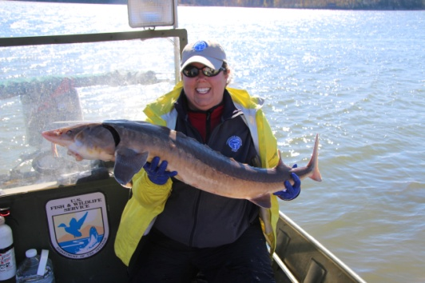

Left: A 48” Lake Sturgeon captured on Chickamauga Reservoir.

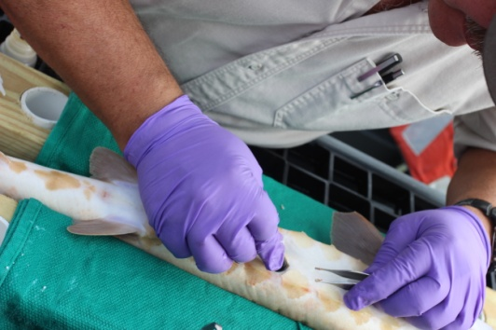

Right: Surgery to implant a sonic tag into a Lake Sturgeon as part of the movement study.

**Southern Appalachian Brook Trout Restoration**

Restoration work with the Southern Appalachian Brook Trout in Tennessee is going very well and 2014 was a banner year for propagation. Nearly 1500 fish were stocked from the Tellico Hatchery and Tennessee Aquarium Conservation Institute in 2014 which is exponentially more fish than in previous years (100 in 2012 and 500 in 2013). In conjunction with Tennessee Tech University Biology Department, 400 tagged juveniles were stocked in both upper Sycamore Creek and Left Prong of Hampton Creek as part of a research study to determine survival of hatchery reared fish. A new stocking site was also added this year. Little Stony Creek in Carter County was identified as a stream suitable for Brook Trout reintroduction so surplus fish produced from Hampton Creek stock were released there after Rainbow Trout removal. Additionally, restoration work continued in lower Sycamore Creek to establish Brook Trout in this reach. Sampling in lower Sycamore Creek has shown that fish stocked since 2012 are surviving in this reach and hopefully we will see signs of recruitment in 2015. This project is continuing in 2015 and a successful spawning season yielded even more eggs than previous years. Techniques developed during this project will be useful in Brook Trout restoration efforts across their range.

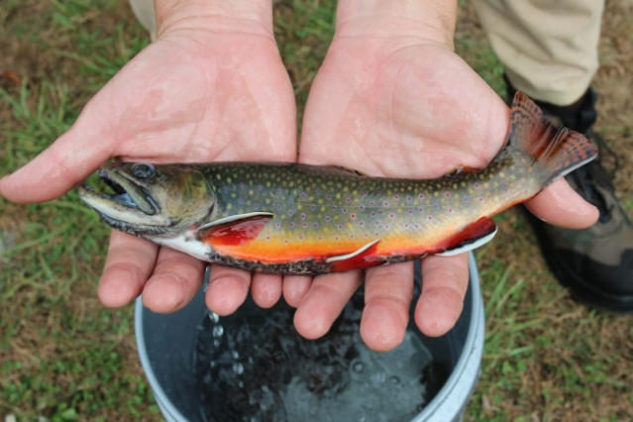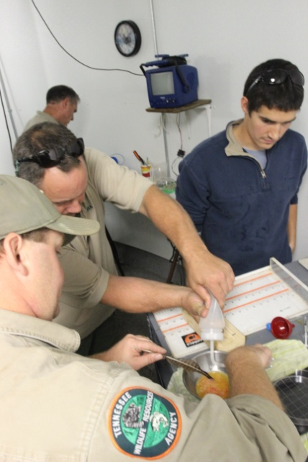

Left: Eggs being fertilized during a spawning event at the Tellico Fish Hatchery.

Right: A 10” wild Brook Trout caught at Hampton Creek.

**2014 Tennessee’s Mollusk Recovery Program Achievements**

A note from Don Hubbs, Mollusk Recovery Program Coordinator:

Similar to 2013, above average rainfall during 2014 challenged TWRA’s efforts toward reintroduction and recovery efforts aimed at restoring freshwater mussel species diversity and distribution in Tennessee. In cooperation with Dr. Paul Johnson at the Alabama Aquatic Biodiversity Center, we were able to reintroduce 802 sub adult federal endangered Pale Lilliput mussels (Toxolasma cylindrellus) into the Duck River. Three additional federal endangered mussel species populations in the Duck River were augmented: fanshell (Cyprogenia stegaria), Cumberlandian Combshell (Epioblasma brevidens), and Fluted Kidneyshell (Ptychobranchus subtentum). Pink mucket populations were augmented in the Clinch and Cumberland rivers with sub adults propagated by Virginia Department of Game and Inland Fisheries (VDGIF) and grown out to stock size by TWRA. Four endangered Cumberlandian mussel species (485 Epioblasma brevidens, 700 Epioblasma capsaeformis, 278 Lemiox rimosus, and 685 Ptychobranchus subtentum) and one state wildlife action plan species Moccasinshells (500 Medionidus conradicus) were stocked into an established restoration site in the Nolichucky River by collecting adult wild stock from the Duck and Clinch rivers, and stocking sub adults produced by VDGIF. The Emory River mussel population was augmented with 149 E. capsaeformis sub adults propagated by VDGIF and 500 adult wild stock Moccasinshells (M. conradicus) collected from the Clinch River. One site in the Hiwassee River was augmented with 500 sub adult E. capsaeformis propagated by Virginia Tech. The Pigeon River site near Wilton Springs was augmented with 562 mussels of five non-listed species.

In total 6,742 mussels of 11 species including 7 federally endangered were stocked into 7 different sites in Tennessee waters during 2014. This work would not be nearly as successful without the assistance of our state partners in Alabama and Virginia. Over 35% of the mussels stocked during 2014 were 1+ year old sub adults provided to TWRA by our partners at Alabama Department Wildlife Resources - Alabama Aquatic Biodiversity Center, VA Tech’s Freshwater Mollusk Conservation Center, and Virginia Department of Game and Inland Fisheries - Aquatic Wildlife Conservation Center in exchange for brood stock to use in their respective restoration programs. Over the past 11 years we have stocked over 50,000 mussels representing 35 species into 10 different rivers at 18 sites across Tennessee.

**TWRA Region I Update**

A note from Tim Broadbent:

We continued maintenance of deep water fish attractors established lake wide and established additional shallow water fish attractors in September and October.  That program is very popular with the anglers.  We have recorded GPS coordinates for our deep water fish attractors and the Kentucky Reservoir fish attractor map is available at <http://www.state.tn.us/twra/fish/Reservoir/TWRA_maps/kylake.pdf>. We have also initiated a cypress tree planting project for Kentucky Reservoir – we are growing the trees to larger sizes and planted over 100 trees in Eagle Creek and the New Johnsonville harbor. Survival the first year was good at Eagle Creek but lower than expected at New Johnsonville.

The silver carp populations continued to increase on the Mississippi River and sampling can be very dangerous.  As reported last year, silver carp have been collected in all Mississippi River tributaries, below the spillway at Reelfoot Lake and below Cheatham Dam. We have also collected silver carp below Pickwick Dam and commercial fishers have continued to collect bighead/silver carp in the Big Sandy area. The Agency is currently working with commercial fishers and private industry to determine commercial sale of Asian carp to China or to local markets. Although the leading edge of distribution is to Pickwick Dam, densities have not increased in the area and reproduction has not been documented.

The stream crew completed assigned surveys (sampled 30 streams and small rivers) and we are in the process of defining the “leading edge” of silver carp distribution in the major rivers, creeks, and streams feeding Kentucky Reservoir.

Trap netting surveys documented good white crappie recruitment at Kentucky and Barkley Reservoirs and Reelfoot Lake; electrofishing surveys showed good populations of largemouth bass on Kentucky, Barkley, and Pickwick Reservoirs.

Sauger populations improved in 2014 but anglers were not able to take advantage of the increased densities because of very high discharge rates during the entire sauger season.. We initiated a sauger stocking program in 2011 and that has continued each year. Sauger appear to produce decent year classes but those fish are not recruiting to harvestable sizes and harvest rates remain below historical levels. Hopefully 2015 will provide good populations and good fishing conditions.

The Fisheries Division has had its plate full this year with Asian carp reports. Asian carp will be our biggest management issue for the future and we are working with private industry and commercial fishers to develop harvest plans.

**Pigeon River Recovery Project 2014**

* Re-introduced 21 species of fish into the Pigeon River system
  + TN – 12 spp. NC – 10 spp.
* Established populations of 7 species
  + TN – Gilt Darter, Stripetail Darter Mountain Brook Lamprey
  + NC – Silver, Telescope, & TN Shiners, Gilt Darter, Banded Darter
* Re-introduced species are found in 43 miles of the Pigeon River and in 4 tributaries (Fines, Jonathan, Crabtree & Richland Creeks)
* Reproduction occurring in 3 additional species:
  + TN – Mountain Madtom
  + NC – Mirror Shiner, Bigeye Chub
* Established 2 genera of snails (*Pleurocera* spp., *Io* sp.) over 230,000 in 11 miles of the Pigeon River in TN
* Introduced 7 species of freshwater mussels, survival and growth have been documented
  + TN – 6 spp. NC – 1 sp.
* Index of Biotic Integrity (IBI) scores for 2014;
  + Denton – 56 good/excellent
  + Tannery – 54 good/excellent (tied its highest score in 2010)
* First occurrence of the Northern Studfish at Tannery Island, TN in 2014
* Conservation Fisheries began propagation of the Tangerine Darter in 2014 with the release into the Pigeon River in TN, planned for the summer of 2015

Current mussel research:

Dr. Mike McKinney( UTK) is comparing the survival and growth of mussels (Wavyrayed Lampmussel and Moccasinshell) in the Pigeon River to those in the Nolichucky River using silos/cages. Preliminary data shows more growth in the mussels in the Nolichucky. Initial results of Wavyrayed Lampmussel and Moccasinshell translocation to the Pigeon and Nolichucky Rivers are summarized below:

Research Updates:

UT Fisheries has two graduate students continuing their research. Melinda Bousfield is completing her dissertation on the analysis of Pigeon River macroinvertebrate data over time and, Phillip Harnage is completing his assessment of macroinvertebrate sampling protocols used to assess the health of the Pigeon River for his thesis. Dr. Mike McKinney’s student, Laura Pullum, is comparing the survival and growth of mussels in the Pigeon River to those in the Nolichucky River using silos/cages and, is looking at the effect of abrasion on the mortality of mussels in the Pigeon River.

**Student Fisheries**

**Tennessee Tech University, Cookeville**

In the past year, Tennessee Tech SFA sent four undergraduates and four graduate students to the Southern Division meeting in Charleston, SC. Our sub-unit also sent several undergraduate and graduate students to the joint meeting of the Tennessee and Mississippi State Chapters in March. This summer we continued a tradition and hosted the 26th annual Kid’s Fishing Derby at Cane Creek Park in Cookeville, Tennessee. Our association assisted at the Army Corps’ Center Hill Lakeshore cleanup. The Tennessee Tech SFA participated in the annual Lake Sturgeon monitoring done by the Tennessee Wildlife Resources Agency (TWRA). Additionally, we assisted with a small impoundment survey and report on Fall Creek Falls, and built habitat improvement structures for a private community near Crossville, TN. We look forward to the SDAFS meeting in Savannah and the Tennessee Chapter meeting in Chattanooga.



Left: Some of the winners from the 26th Annual Kid’s Fishing Derby at Cane Creek Park in Cookeville, TN

**University of Tennessee, Knoxville**

Last spring The University of Tennessee at Knoxville’s Wildlife and Fisheries Society welcomed a new advisor, Dr. Brian Alford. We have been working closely with him to improve our fisheries activity through volunteer work and campus research. This semester we have volunteered with the Tennessee Valley Authority as they have conducted Biotic Integrity sampling, which gave some of our members valuable experience with field techniques such as backpack electroshocking, seining and data collection.

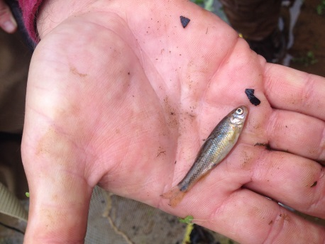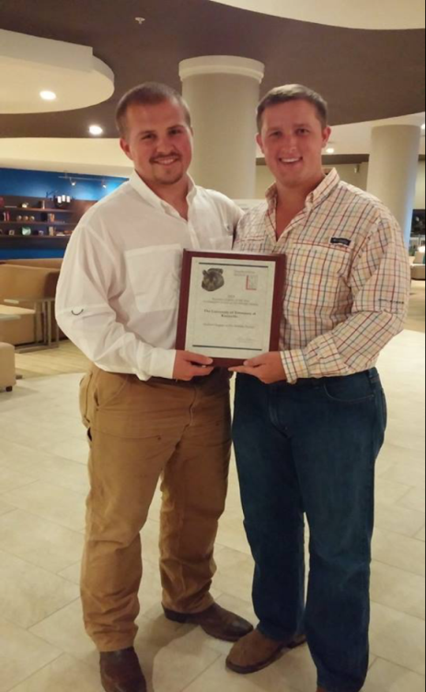

Left: Caylor Romines (President) and Nathan Wilhite (Vice President) accepting Southeastern Chapter of the Year Award.

A new project we have set up on campus is a lake sturgeon care project, which involves a team of students active in the chapter feeding and looking after two eight year old sturgeons. We have set this up in a classroom on our campus, which will provide us with experience caring for an endangered aquatic species as well as an education project for years to come.

Above: Flame Chub, *Hemitremia flammea* caught while conducting the IBI sampling at Town Creek.

Our chapter held its first annual Fall Fish Fry on November 1st for its members and their families in order to fundraise for future fisheries projects within the society. This provides a time for students and faculty to come together and enjoy a good meal while supporting our undergraduate work opportunities. We will be hosting our Annual Wild Game Dinner on February 7th 2014.

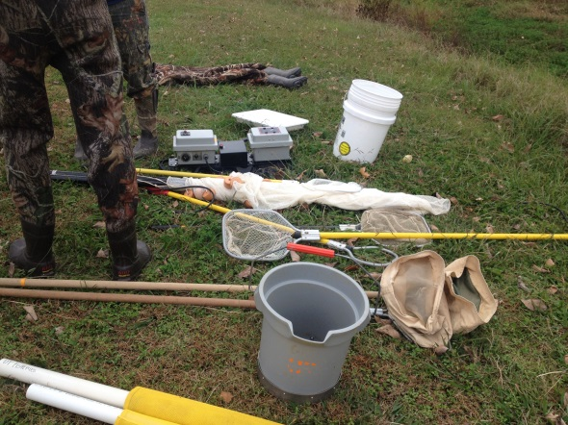Due to our hard work and many accomplishments this year, our chapter was recently awarded Student Chapter of the Year at the Southeastern Association of Fish and Wildlife Agencies.

Members volunteered in November with TVA at Lenoir City High School and educated students about native darters as they sampled Town Creek.

To the left is the sampling equipment we used to conduct an Index of Biotic Integrity.

**News from Conservation Fisheries, Inc. (CFI)**

Conservation Fisheries, Inc. (CFI) continues to propagate, stock, and monitor smoky and yellowfin madtoms, Citico darters, and spotfin chubs in Tellico River with evidence of reproduction and good numbers of smokies & Citico darters, though no yellowfins were observed. Spotfin chubs were observed at several sites, and for a second year observed at Oosterneck Creek, approximately two river miles above the nearest release site. Sampling effort this year (and consequently number of fish observed per unit effort) was decreased from prior years due to implementing a new long-term monitoring protocol in Citico Creek similar to the Abrams Creek protocol with plans for expansion in Tellico River in order to eventually compare all populations more quantitatively. Quantitative monitoring of restored Citico darter and smoky and yellowfin madtom populations in Abrams Creek was continued a third year by Great Smoky Mountains National Park. Results will be compiled and compared to the first and second years as well as data from similar application of the protocol at six sites in Citico Creek this year. The data collected will provide baseline information and quantify long-term population trends and reproductive success, providing a model for similar future monitoring in Tellico River, and possibly elsewhere.

Efforts to propagate and restore Emory River spotfin chubs and Elk River boulder darters to Shoal Creek continue. A record number of young boulder darters were produced at CFI this year (~2000 young) with many already tagged and stocked at new upstream sites above Factory Branch. Monitoring in Shoal Creek detected only one spotfin chub, but 13 boulder darters were observed at three sites, including 9 wild-spawned individuals, one at a site never stocked. In the Elk River during collection of 12 broodstock an incredible 39 boulder darters were captured at Harms Mill on March 24, surely a record number for the species in a single effort/locality!

Following up on last year’s Conasauga River float and snorkel surveys for *Percina jenkinsi* above the US 411 Bridge was a float this year below the bridge. Although 10 of the logperch were observed at the first site downstream, only Mobile logperch were detected at any other sites downstream (contrary to surveys in spring 2012).

A new project was initiated as a part of the Corps of Engineers agreed-upon Capture and Hold conservation measures described in the Final Biological Opinion on the Wolf Creek Dam/Lake Cumberland Return to Historical Pool Level Operations, Russell County, Kentucky. It involves holding, propagation, and long term maintenance of an ark/refugium population of tuxedo darters collected at the sites determined to be impacted by the return to historical operations of Lake Cumberland. CFI collected broodstock during concurrent (and separately funded) efforts to monitor local populations and capture fish for acquisition of tissue samples (fin clips) for a study of genetic diversity in the species throughout its range in the Big South Fork Cumberland River. Only 30 specimens taken from the lowest portions of the river impacted by Lake Cumberland lake level operations were retained as broodstock for the captive population at CFI. This effort is intended to ensure that some genetic diversity of the impacted tuxedo darter populations will be conserved and will provide the necessary genetic stock to repopulate the Big South Fork in the event of loss of those populations. In addition, it also has the potential to increase the distribution of the species within the Big South Fork and/or other suitable streams by providing individuals that could be used in reintroduction and population augmentation efforts to further the species' recovery.

In another new project CFI has developed captive propagation methods for the bluemask darter and produced a small number of young. The USFWS recently determined that a proposed bluemask darter reintroduction is appropriate and a necessary step in achieving recovery of the species, and would fulfill two bluemask darter Recovery Plan objectives. Efforts to reintroduce bluemask darter could increase the total amount of habitat occupied by the species, thereby reducing the risk of extinction and loss of genetic diversity. Funding was provided by USFWS, TWRA and TVA. In conjunction with propagation efforts, snorkel field observations successfully recorded bluemask darters spawning in the Collins River on April 24: [bluemask spawning video](http://vimeo.com/92931171).

Hatchery spawning and rearing included the following additional species/populations in 2014: tangerine darter, marbled darter, Barrens topminnow, ashy darter, slackwater darters, spring pygmy sunfish, Kentucky arrow darter, Cumberland darter, and diamond darters (again unsuccessful!). CFI will attempt to further refine already-developed captive propagation techniques for the production and collection of diamond darter eggs and larvae, but utilize the closely related crystal darter as a surrogate to avoid collection of any additional diamond darters until success with the surrogate species is obtained.CFI hopes to determine larval microhabitat conditions and prey item(s) necessary for survivorship and development; in particular, by utilizing larvae of sand darters (*Ammocrypta* sp.).

Additional field observations of note included another five ashy darters in the Little River (3 captured for broodstock), as well as numerous sickle darters and wild-spawned marbled darters at a newly established upstream locality.

Website info: [www.conservationfisheries.org](http://www.conservationfisheries.org) & <http://www.facebook.com/pages/Conservation-Fisheries/377299094501>